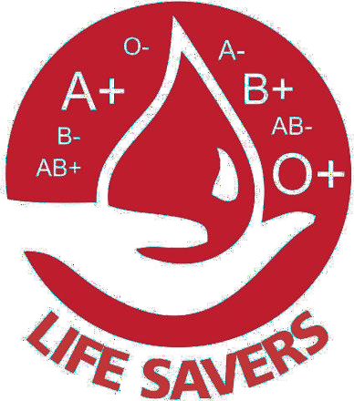

BLOOD DONATION

## INTRODUCTION

**BLOOD DONATION** is a website based on ASP.net. The purpose of this project was to develop a independent blood management information system to assist people in organization or organization to request blood donation from people who are interested in donating.

## ADMIN ARE OF A TWO TYPES

* + 1. **Donors**

Donors are interested in giving donation to a request from seeker, they login with username and password and their feed should be the organizations requests for donation, donors can accept or ignore the request.

## Organization or seeker in organization

Seekers are organization or people in organization need immediate donation, organization have their feed is to request donation**.**

## MAIN PAGE

* + 1. **MAIN WINDOW**

The BLOOD BANK MANAGEMENT SYSTEM is great project. this project is designed for successful completion of project on blood bank management system. the basic building aim is to provide blood donation service to the city recently. Blood Bank Management System (BBMS) is a browser-based system that is designed to store, process, retrieve and analyze information concerned with the seek help within a blood bank. This project aims at maintaining all the information pertaining to blood donors, different blood groups available le in each blood bank and help them manage in a better way.

## 2. DIAGRAMS

* 1. **WORKFLOW DIAGRAM**

A **workflow diagram** is a visual representation of a business **process** (or **workflow**), usually done through a flowchart. It uses standardized symbols to describe the exact steps needed to complete a **process**, as well as pointing out individuals responsible for each step.

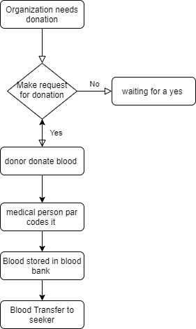

Fig (2): Workflow

## DATABSE BUISNESS RULES

Business rules describe the *business policies* that apply to the data stored on a company's databases. In other words, business rules reflect how a business perceives its use of data. Some business rules are especially important to the database designer because they can be incorporated into the *logical schema* of the database. There are certain *constraints* that designers apply to ensure that a database honours a company’s business rules. These constraints help preserve *data integrity*. Business-rules constraints fall into two categories:

* + 1. **field constraints *within* tables, and**
    2. **relationship constraints *between* tables**
* All organizations must have name, phone, type, address: city state, street, and a unique ID which cannot be null.
* organization send a request, needs a donation that will display to the donors.
* Many organizations can send a request and many donors can respond to request from the organization, however, a feedback must be sent to the organization.
* Donors who respond to the request their feedback will be sent to the organization and if no donors respond the feedback will be empty which is a no respond will be send to the organization.
* Each donor can donate with many bloods’ packages.
* Each blood will have only one donor.
* Each Donor will have Name, phone, address, and ID which cannot be null.
* Each blood has blood type, Date, Quantity, and unique blood ID, constrains placed on blood type field that must only have A, B, AB, and O and all attributes cannot be null.
* Medical person must barcode the blood packages.
* Blood packages must be barcode by one medical person.
* Medical persons barcode many bloods packages.
* The Blood Bank has Blood Types, Date, Quantity, and unique Transfer ID which constrains that must not be null.
* Blood bank can have many bloods packages.
* Bloods packages will only have one blood bank.
* Organization will have only one blood bank.
* Blood bank can send blood to many organizations.
* Organizations will have only one blood bank receive blood from.

## INTRODUCTION ERD DIAGRAM

The entity-relationship data model is based on a perception of a real world that consists of a collection of basic objects called entities and of relationships among these objects. An entity is an

“object” in the real world that is distinguishable from other objects.

The logical structure of a database can be expressed graphically by an E- R diagram consists of the following major components:

# ENTITY

An entity is an “object” in the real world that is distinguishable from all other objects. An entity set is a set of entities of the same type that share the same attributes.

## ATTRIBUTE

* + 1. **KEY ATTRIBUTE**

A key attribute is the unique, distinguishing characteristic of the entity. For example, Guest ID might be the guest’s key attribute.

## RELATIONSHIPS

A relationship an association among several entities.

## RELATIONSHIP

**For e . g . ,** we can define a relationship that associates customer Jon with Room 142.This relationship specifies that Jon is a customer with Room No.142.

# While using E-R-D diagrams, we can follow certain guidelines, which are as follows:

* Unnecessary attributes should not beintroduced.
* A complex entity should be simplified by decomposing a complex attribute into sub attributes.
* We should generalize or specialize wherever possible and appropriate. Generalization is the result of taking the union of several lower entity sets to produce higher- level entity set.

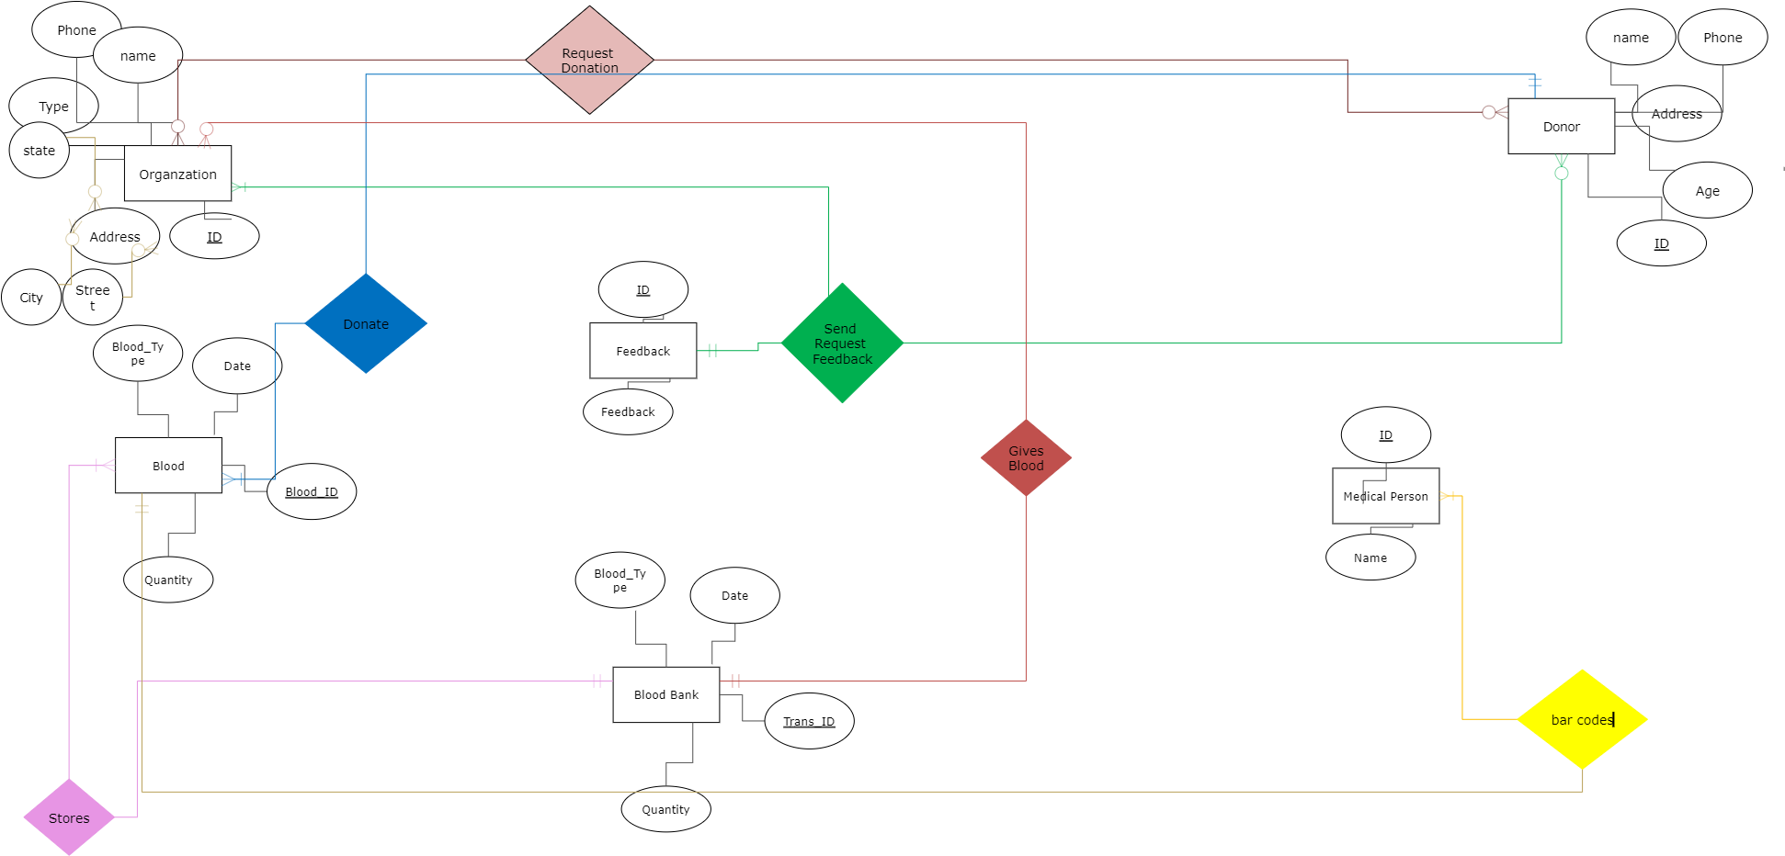

Fig (2): ERD-Blood Donation Diagram

## Mapping

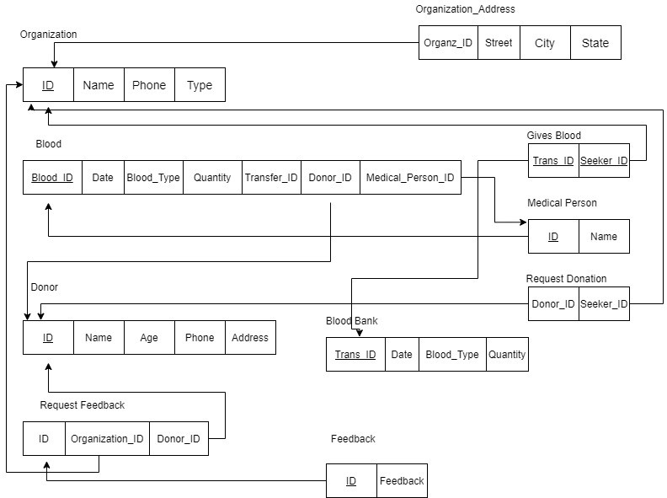

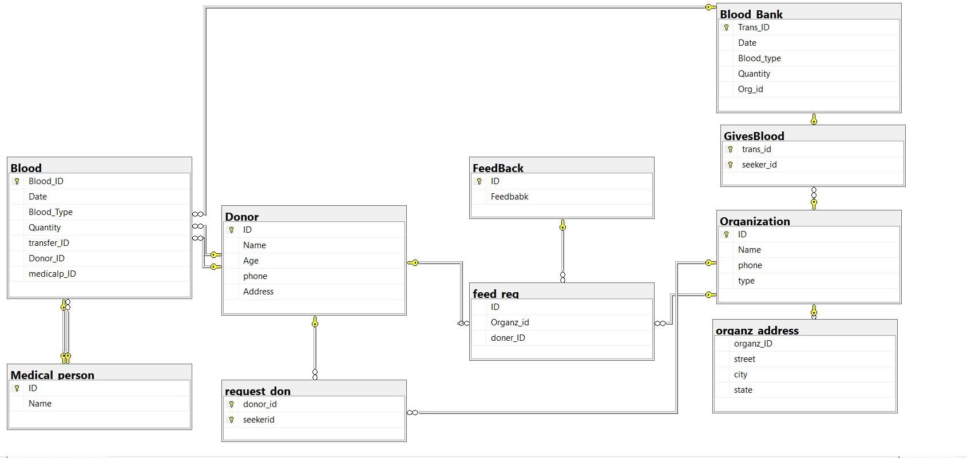

* 1. **FD’s and Normalization 1st normal form**

## As Address attribute which is a composite attribute We make in separate table with foreign key .

|  |  |  |  |
| --- | --- | --- | --- |
| **City** | **state** | **street** | **ID** |

**If we have composite or multi-value entity 2nd Normal Form**

**Many to Many**

|  |  |  |  |  |  |  |  |  |  |  |  |  |  |  |  |  |  |  |  |
| --- | --- | --- | --- | --- | --- | --- | --- | --- | --- | --- | --- | --- | --- | --- | --- | --- | --- | --- | --- |
|  |  | |  | |  | |  | |  |  |  | |  | |  | | |  |  |
| **Organ_ID** | | **Donor_ID** | | **Org_Name** | | **Org_Phone** | | **Org_Address** | | **Org_Type** | | **Don_Name** | | **donPhone** | | **donAddress** | **DAge** | | |
| **12** | | **11** | | **Hopstial-1** | |  | |  | |  | | **Ahmed** | |  | |  |  | | |
| **13** | | **11** | | **Hopstial-2** | |  | |  | |  | | **Ahmed** | |  | |  |  | | |
|  | |  | |  | |  | |  | |  | |  | |  | |  |  | | |

|  |  |  |  |  |
| --- | --- | --- | --- | --- |
| **Organ_ID** | **Org_Name** | **Org_Phone** | **Org_Address** | **Org_Type** |
| **12** | **Hopstial-1** |  |  |  |
|  |  |  |  |  |
| **13** | **Hopstial-2** |  |  |  |
|  |  |  |  |  |

|  |  |  |  |  |
| --- | --- | --- | --- | --- |
| **Donor_ID** | **Don_Name** | **donPhone** | **donAddress** | **DAge** |
| **11** | **Ahmed** |  |  |  |
| **11** | **Ahmed** |  |  |  |
|  |  |  |  |  |

**3rd normal form**

1 to many

As the donation between blood and donor

|  |  |  |  |  |  |  |  |  |  |
| --- | --- | --- | --- | --- | --- | --- | --- | --- | --- |
|  | | | | | | | | | |
|  | | | | | | | | | |
| **Blood_ID** | **Quantity** | **Type** | **Donor ID** | **Name** |  |  |  |  |  |
| **1222** | **1** | **A** | **1112** | **Ahmed** |  |  |  |  |  |
| **13** | **2** | **A** | **1112** | **Ahmed** |  |  |  |  |  |
|  |  |  |  |  |  |  |  |  |  |

DonorID determine the and Donor is attribute in this case called transitive

|  |  |  |
| --- | --- | --- |
| Blood ID | Quantity | Type |
|  |  |  |

|  |  |
| --- | --- |
| Donor ID | Name |
|  |  |